Formulir Permintaan Data Patch | 

INFORMASI PEMOHON
NAMA | : Jane Angel Brilian Natasya
JABATAN | : Product Owner AO PS
UNIT KERJA | : Digital
TANGGAL PERMOHONAN | : 23 Juli 2025

Tujuan Patching :
Permohonan patching data ini dilakukan terkait dengan adanya permohonan pembatalan Polis LifeChance yang telah diterima dan diproses secara manual oleh tim Policy Service dan Customer Management Sebagai berikut:

NO | NO POLIS | NAMA | TGL SURRENDER
1 | 800325000112324 | JEFRY DWI PRANATA | 23 Juli 2025

Detail Patching:
Perubahan data pada system new core mencakup :

- Mengubah status polis menjadi SURRENDER
- Mengubah status coverage polis menjadi INACTIVE
- Mengubah status relasi polis menjadi INACTIVE
- Mengubah tanggal end coverage date sesuai dengan tanggal surrender

Script | - Surrender  Polis 800325000112324  -------------Update status polis------------------  curl --location --request PUT 'https://api-automation.ifg-life.id/v2/ao-new-business/policies/status' \  --header 'Content-Type: application/json' \  --header 'apiKey: vAmqizKATOVgM5PCJ5EhUwi0S193VZn2' \  --data '{  "policyId":"5fbf09be-87e1-4b14-b9dd-551c53af9419",  "status": "SURRENDER",  "actionCode": "SUBMITTED",  "updatedBy": "BPMN_PS"  }'  -----------Update status coverage--------------  curl --location --request PATCH 'https://api-automation.ifg-life.id/v2/ao-new-business/policies/coverage/5fbf09be-87e1-4b14-b9dd-551c53af9419' \  --header 'Content-Type: application/json' \  --header 'apiKey: vAmqizKATOVgM5PCJ5EhUwi0S193VZn2' \  --data '{  "listPolicyCoverage":  [  {  "id": "7b343f8b-0f01-4bc2-ac65-d0c3e9b5d12d",  "code": "CI_CATEGORY_1",  "type": "BENEFIT",  "benefit": 442478000,  "premium": 0,  "startCoverage": "2025-06-25 00:00:00",  "endCoverage": "2025-07-23 00:00:00",  "planCode": "02",  "status": "INACTIVE",  "createdBy": "BPMN_UW",  "createdAt": "2025-06-25 16:25:16",  "updatedBy": "BPMN_PS",  "updatedAt": "2025-07-24 00:00:00",  "extraValue": 0,  "parentId": null,  "sub": null  },  {  "id": "c352eb85-af63-4652-a7ba-d82c7d910f16",  "code": "CI_CATEGORY_2",  "type": "BENEFIT",  "benefit": 442478000,  "premium": 0,  "startCoverage": "2025-06-25 00:00:00",  "endCoverage": "2025-07-23 00:00:00",  "planCode": "02",  "status": "INACTIVE",  "createdBy": "BPMN_UW",  "createdAt": "2025-06-25 16:25:16",  "updatedBy": "BPMN_PS",  "updatedAt": "2025-07-24 00:00:00",  "extraValue": 0,  "parentId": null,  "sub": null  },  {  "id": "70ad9dbd-d231-4f2e-a00e-3c96af6156df",  "code": "CI_CATEGORY_3",  "type": "BENEFIT",  "benefit": 442478000,  "premium": 0,  "startCoverage": "2025-06-25 00:00:00",  "endCoverage": "2025-07-23 00:00:00",  "planCode": "02",  "status": "INACTIVE",  "createdBy": "BPMN_UW",  "createdAt": "2025-06-25 16:25:16",  "updatedBy": "BPMN_PS",  "updatedAt": "2025-07-24 00:00:00",  "extraValue": 0,  "parentId": null,  "sub": null  },  {  "id": "a1dc40a9-86fc-4837-a9cd-db1d3b8609e7",  "code": "CI_CATEGORY_4",  "type": "BENEFIT",  "benefit": 442478000,  "premium": 0,  "startCoverage": "2025-06-25 00:00:00",  "endCoverage": "2025-07-23 00:00:00",  "planCode": "02",  "status": "INACTIVE",  "createdBy": "BPMN_UW",  "createdAt": "2025-06-25 16:25:16",  "updatedBy": "BPMN_PS",  "updatedAt": "2025-07-24 00:00:00",  "extraValue": 0,  "parentId": null,  "sub": null  },  {  "id": "3dca076f-4af8-433f-b4e8-14f631dc493c",  "code": "CI_CATEGORY_5",  "type": "BENEFIT",  "benefit": 442478000,  "premium": 0,  "startCoverage": "2025-06-25 00:00:00",  "endCoverage": "2025-07-23 00:00:00",  "planCode": "02",  "status": "INACTIVE",  "createdBy": "BPMN_UW",  "createdAt": "2025-06-25 16:25:16",  "updatedBy": "BPMN_PS",  "updatedAt": "2025-07-24 00:00:00",  "extraValue": 0,  "parentId": null,  "sub": null  },  {  "id": "f264d61b-43a8-4d28-b2f8-712b92a20a0b",  "code": "CI_CATEGORY_6",  "type": "BENEFIT",  "benefit": 44247800,  "premium": 0,  "startCoverage": "2025-06-25 00:00:00",  "endCoverage": "2025-07-23 00:00:00",  "planCode": "02",  "status": "INACTIVE",  "createdBy": "BPMN_UW",  "createdAt": "2025-06-25 16:25:16",  "updatedBy": "BPMN_PS",  "updatedAt": "2025-07-24 00:00:00",  "extraValue": 0,  "parentId": null,  "sub": null  },  {  "id": "85cc5db1-8fd9-41fb-b744-05315d647006",  "code": "EXTRA_PREMIUM",  "type": "EXTRA_PREMIUM",  "benefit": 0,  "premium": 0,  "startCoverage": "2025-06-25 00:00:00",  "endCoverage": "2025-07-23 00:00:00",  "planCode": "02",  "status": "INACTIVE",  "createdBy": "BPMN_UW",  "createdAt": "2025-06-25 16:25:16",  "updatedBy": "BPMN_PS",  "updatedAt": "2025-07-24 00:00:00",  "extraValue": 0,  "parentId": null,  "sub": null  },  {  "id": "2c8e6e17-07a5-4b1b-88e3-3133392e7f47",  "code": "MAIN_PREMIUM",  "type": "PREMIUM",  "benefit": 0,  "premium": 200000,  "startCoverage": "2025-06-25 00:00:00",  "endCoverage": "2025-07-23 00:00:00",  "planCode": "02",  "status": "INACTIVE",  "createdBy": "BPMN_UW",  "createdAt": "2025-06-25 16:25:16",  "updatedBy": "BPMN_PS",  "updatedAt": "2025-07-24 00:00:00",  "extraValue": 0,  "parentId": null,  "sub": null  }  ]  }'  -----------------Update status relation----------------------  curl --location --request PATCH 'https://api-automation.ifg-life.id/v2/ao-new-business/policies/relation/5fbf09be-87e1-4b14-b9dd-551c53af9419' \  --header 'Content-Type: application/json' \  --header 'apiKey: vAmqizKATOVgM5PCJ5EhUwi0S193VZn2' \  --data '{  "listPolicyRelation":[  {  "id": "193af6d8-216d-48c3-91b6-1a0b4df1f1ba",  "personCIF": "85884bf2-4d6d-4e41-96f6-8973a7e1e1a6",  "policyBeneficiary": null,  "policySubstandard": [],  "policyExclusion": [],  "role": "PH",  "startDate": "2025-06-25 16:25:15",  "endDate": "2025-07-23 16:25:15",  "status": "INACTIVE",  "createdBy": "BPMN_UW",  "createdAt": "2025-06-25T16:25:16.819643",  "updatedBy": "BPMN_PS",  "updatedAt": "2025-07-24 00:00:00"  },  {  "id": "9a1ff5fe-bec5-4c09-82f6-f7e99c4fd1c2",  "personCIF": "85884bf2-4d6d-4e41-96f6-8973a7e1e1a6",  "policyBeneficiary": null,  "policySubstandard": [],  "policyExclusion": [],  "role": "PY",  "startDate": "2025-06-25 16:25:15",  "endDate": "2025-07-23 16:25:15",  "status": "INACTIVE",  "createdBy": "BPMN_UW",  "createdAt": "2025-06-25T16:25:16.82367",  "updatedBy": "BPMN_PS",  "updatedAt": "2025-07-24 00:00:00"  },  {  "id": "64f2355c-31d7-4b21-8dd2-c9237be732cc",  "personCIF": "85884bf2-4d6d-4e41-96f6-8973a7e1e1a6",  "policyBeneficiary": null,  "policySubstandard": [],  "policyExclusion": [],  "role": "IN",  "startDate": "2025-06-25 16:25:15",  "endDate": "2025-07-23 16:25:15",  "status": "INACTIVE",  "createdBy": "BPMN_UW",  "createdAt": "2025-06-25T16:25:16.826582",  "updatedBy": "BPMN_PS",  "updatedAt": "2025-07-24 00:00:00"  },  {  "id": "3aa10cdf-a2f3-4e5a-bce4-1de0a554dec6",  "personCIF": "647e5624-1423-41e3-9f63-b5d1f03a6bd7",  "policyBeneficiary": {  "id": "172b31df-d606-46b0-a1f9-b796f3c8839b",  "relationType": "ISTRI",  "percentage": 100  },  "policySubstandard": [],  "policyExclusion": [],  "role": "BN",  "startDate": "2025-06-25 16:25:15",  "endDate": "2025-07-23 16:25:15",  "status": "INACTIVE",  "createdBy": "BPMN_UW",  "createdAt": "2025-06-25T16:25:16.830913",  "updatedBy": "BPMN_PS",  "updatedAt": "2025-07-24 00:00:00"  }  ]  }'
2. Hasil data patch yang dibutuhkan dan diuji di lingkungan testing | Polis yang digunakan untuk simulasi Patch Surrender LifeChance di UAT 800325000168015:  - Status polis menjadi SURRENDER  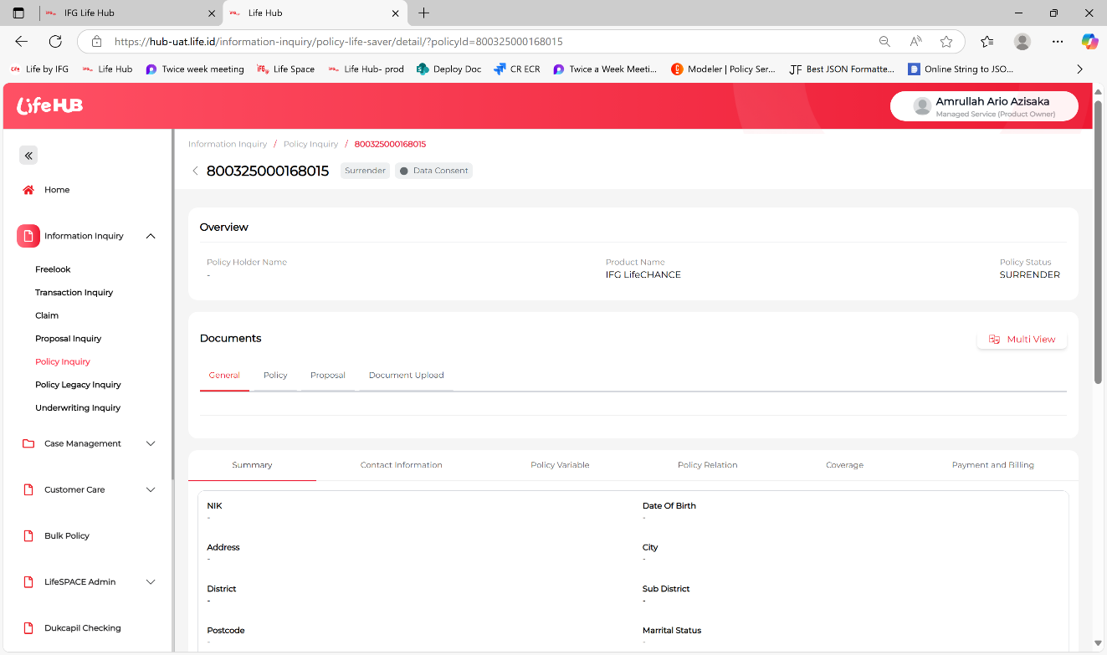  - Status policy coverage menjadi INACTIVE  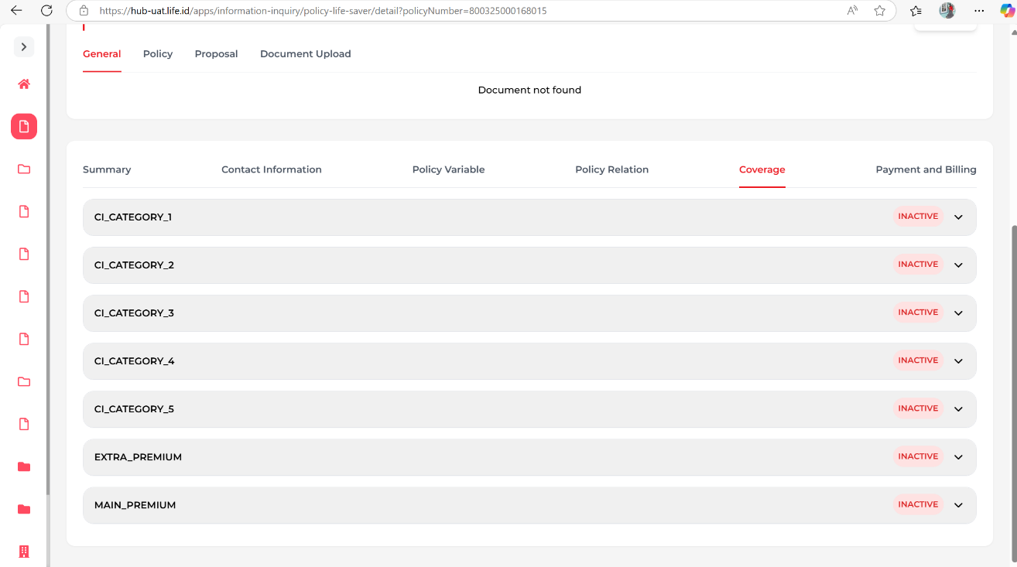  - Status policy relation menjadi INACTIVE  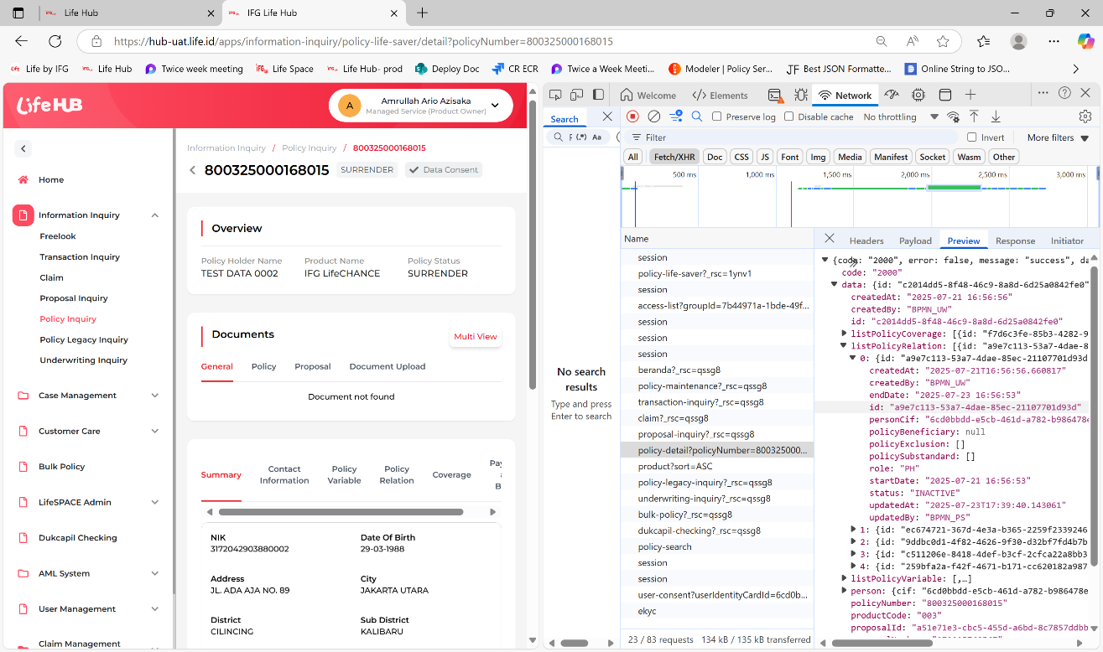
Email Permintaan User | 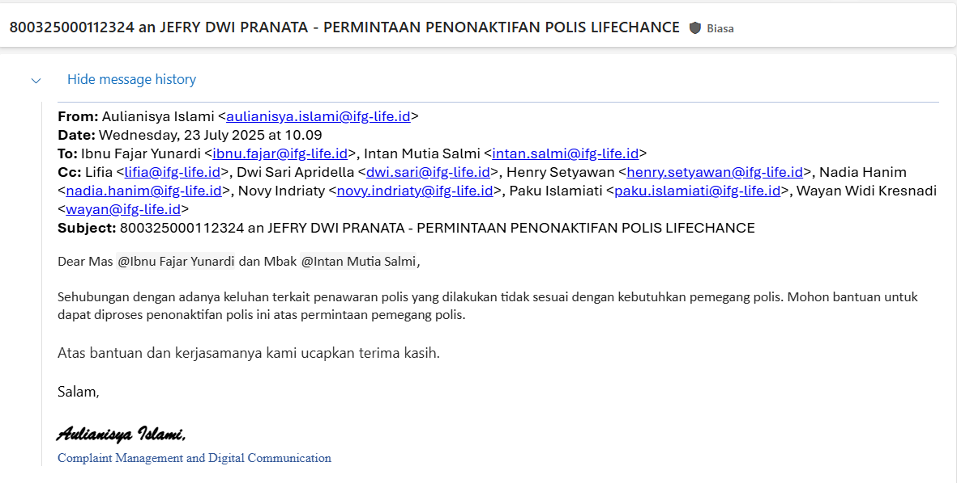

Nama | Jabatan | Tanggal | Tanda Tangan
Bagus Febriantyo Putra | Policy Maintenance Officer | 23/07/2025
Intan Mutia Salmi | NB and PS Plaform Lead | 23/07/2025
Triana Mustika Rukmi | Head of Operation Platform | 24/07/2025
Adrian Putra Taslim | Head of Digital | 24/07/2025
Garry Alfanzo | Head of Enterprise Architecture and Platform Lead | 24/07/2025
Wilhan Tjahjadi | Head of IT Governance | 24/07/2025
A Syafrie Zen | Head of IT and Operation Governance | 24/07/2025
Iskak Hendrawan | Direktur Ops & TI | 24/07/2025

